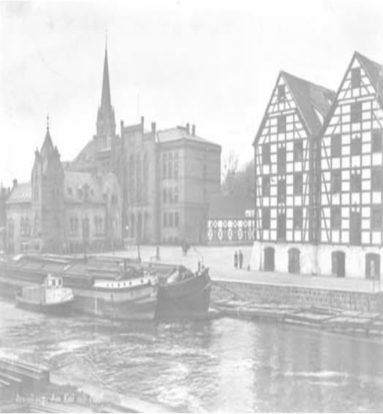

Participation form

Waterways revitalisation as a chance
for the development of tourism and recreation

September 12th-13th 2011

Name.................................................................... Surname ..................................................................
Academic degree/ specialisation………………………………… .........................................................................
Institution ................................................................................................................................................
..................................................................................................................................................................
Address.....................................................................................................................................................
………………………………………………….Phone number/fax..............................................................................
e-mail.............................................................

Subject of the paper:………………………………………………………………………………………………………………………………..
………………………………………….……………………………………………………………………………………………………………………..
…………………………………………………………………………………………………………….....................................................

- I wish to participate in the guided tour of Bydgoszcz

Participation form should be sent via email zgt@ukw.edu.pl Or fax 52 349-62-50 50 until February 28th 2011

